**Sanjivani College of Engineering,**

**Department of Computer Engineering.**

**DATABASE MANAGEMENT SYSTEM LABORATORY.**

* Name: Nikita Rajendra Bhawar
* Class: SY A
* Roll No.:18
* PRN No. : UCS21F1018
* Assignment No.:3
* Problem Statement:-

Unnamed PL/SQL code block: Use of Control structure and Exception handling is mandatory. Write a PL/SQL block of code for the following requirements:-

Schema: 1. Borrower(Rollin, Name, DateofIssue, NameofBook, Status) 2. Fine(Roll_no,Date,Amt)

● Accept roll_no & name of book from user.

● Check the number of days (from date of issue), if days are between 15 to 30 then fine amount will be Rs 5 per day.

● If no. of days>30, per day fine will be Rs 50 per day & for days less than 30, Rs. 5 per day.

● After submitting the book, status will change from I to R.

● If condition of fine is true, then details will be stored into fine table. Frame the problem statement for writing PL/SQL block inline with above statement.

Code:-

* **To Create Database library:-**

Create database library;

use library;

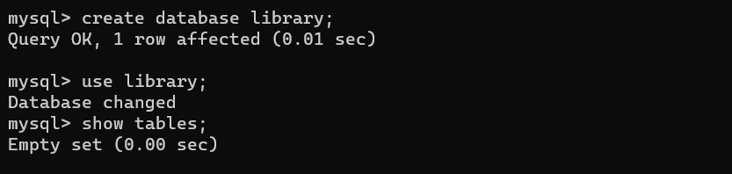show tables;

* **To create table Borrower and fine:-**

create table borrower(rollno int primary key,name varchar(20),dateofissue date,nameofbook

varchar(20),status varchar(20));

create table fine(rollno int,foreign key(rollno) references borrower(rollno),returndate date,

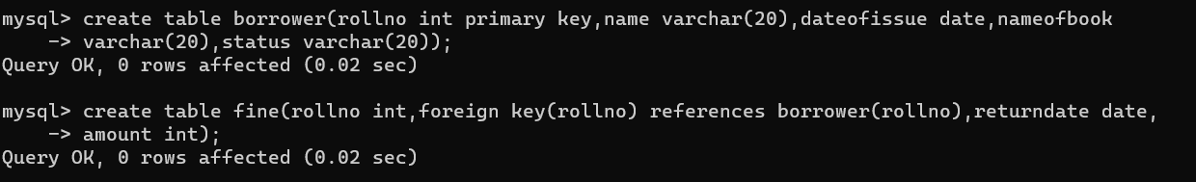amount int);

* **To insert values in borrower:-**

insert into borrower values(1,'abc','2021-06-01','SEPM','I');

insert into borrower values(2,'xyz','2021-05-01','OOP','I');

insert into borrower values(3,'pqr','2021-06-15','DBMS','I');

insert into borrower values(4,'def','2021-06-30','DSA','I');

insert into borrower values(5,'lmn','2021-07-05','ADS','I');

select * from borrower;

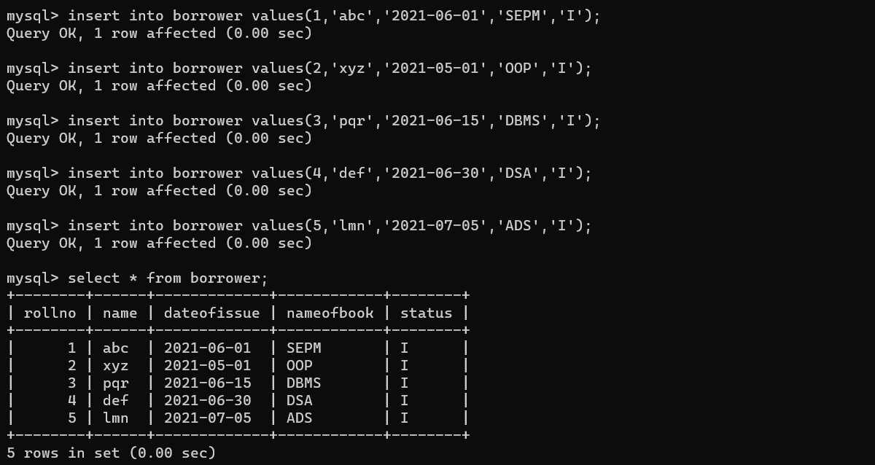

* **Main code:-**

delimiter $

create procedure calc_fine_lib(in roll int)

begin

declare fine1 int;

declare noofdays int;

declare issuedate date;

declare exit handler for SQLEXCEPTION select 'create table definition';

select dateofissue into issuedate from borrower where rollno=roll;

select datediff(curdate(),issuedate) into noofdays;

if noofdays>15 and noofdays<=30 then

set fine1=noofdays*5;

insert into fine values(roll,curdate(),fine1);

elseif noofdays>30 then

set fine1=((noofdays-30)*50) + 30*5;

insert into fine values(roll,curdate(),fine1);

else

insert into fine values(roll,curdate(),0);

end if;

update borrower set status='R' where rollno=roll;

end $

delimiter ;

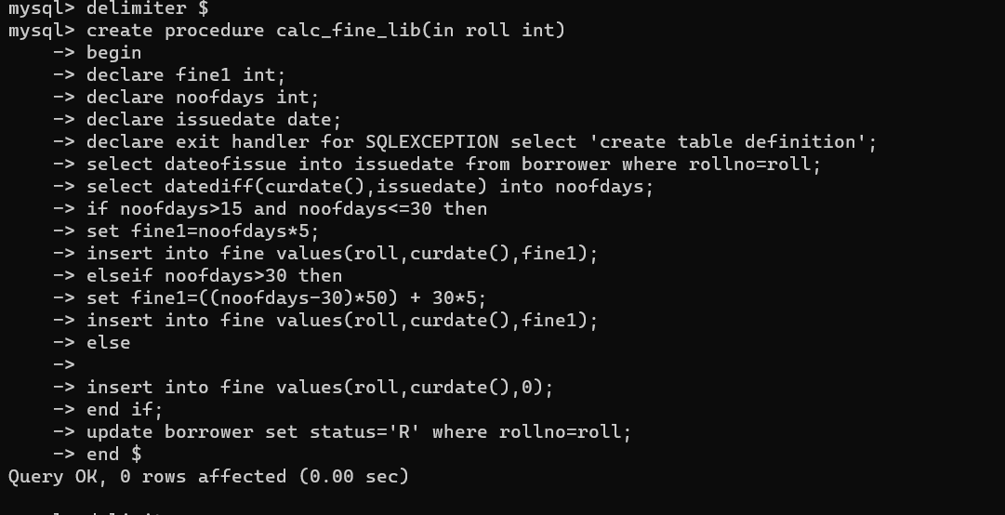

call calc_fine_lib(1);

call calc_fine_lib(2);

call calc_fine_lib(3);

call calc_fine_lib(4);

call calc_fine_lib(5);

select * from fine;

